## PROGRAM DEFINITION

|  |
| --- |
|  |
| * Program untuk distribute invoice ke email tenant |

## RELATED TABLES

|  |  |
| --- | --- |
|  | **Access** |
| * PMT_TRANS_HD * PMT_AGREEMENT | * RW |

## ROLES

|  |  |
| --- | --- |
|  | **Test** |
| * User yg mempunyai akses ke program |  |

## MAIN FORM

### USER INTERFACE

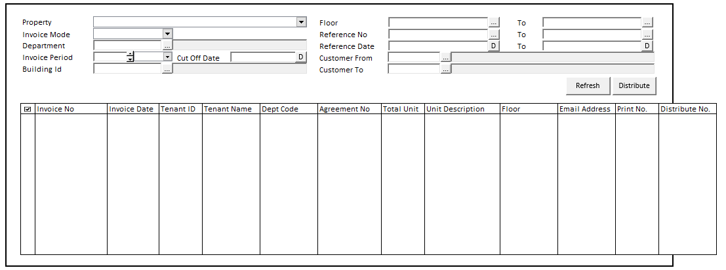

#### INITIAL VERSION

|  |  |
| --- | --- |
|  | **Test** |
| * Set VAR_COMPANY_ID = Login User’s Company ID * Set VAR_USER_ID = Login User ID * Set VAR_LANGUAGE_ID = Login User’s Language ID * Get Property List to Combobox Property [PROPERTY_LIST]:   EXEC RSP_GS_GET_PROPERTY_LIST ‘VAR_CCOMPANY_ID’, ‘VAR_LANGUAGE_ID’  Set Value : CPROPERTY_ID Set Display : CPROPERTY_NAME  As Parameter: CPROPERTY_ID   * Jalankan RSP_GS_GET_PERIOD_YEAR_RANGE dengan parameter, simpan hasil ke VAR_GSM_PERIOD   + VAR_COMPANY_ID   + ‘’ (Empty String)   + ‘’ (Empty String) * Jalankan RSP_CB_GET_SYSTEM_PARAM dengan parameter, simpan hasil ke VAR_CB_SYSTEM_PARAM   + VAR_COMPANY_ID   + VAR_LANGUAGE_ID |  |

### BUTTON DEFINITION -CR1

|  |  |  |
| --- | --- | --- |
| **Button Name** | **Action** | **Validation** |
| Refresh | Jalankan ACTION REFRESH |  |
| Distribute | Jalankan DISTRIBUTE PROCESS | Enabled hanya jika ada data pada grid |

### DISPLAY PROCESS

#### FIELD DEFINITION

|  |  |  |  |
| --- | --- | --- | --- |
| **Name** | **Field** | **Type** | **Validation** |
| Property | Set Value : CPROPERTY_ID  Set Display : CPROPERTY_NAME  As Parameter: CPROPERTY_ID | Combobox | * Mandatory * Get DataSource from [PROPERTY_LIST] * IF Combobox Empty   + Display message “Please select property !” |
| Invoice Mode | As Parameter: CINVOICE_MODE | Combobox  Isi combobox dengan RSP_PM_GET_INVOICE_MODE_LIST dengan parameter:   * VAR_COMPANY_ID * Selected CPROPERTY_ID * VAR_USER_ID   Set Item Code=CCODE  Set Item Name=CDESCRIPTION | * Default Value = “I” (Invoice) |
| Department | * CDEPT_CODE * CDEPT_NAME * Value : CDEPT_CODE | Textbox & Button Lookup | * Department Name always disabled * Dept Code & button lookup always enabled * Do Lookup GSL00710 DEPARTMENT PROPERTY LOOKUP, Parameter:   + VAR_COMPANY_ID   + Selected Property ID (CPROPERTY_ID)   + VAR_USER_ID * Set CDEPT_CODE = lookup.CDEPT_CODE * Set CDEPT_NAME = lookup.CDEPT_NAME |
| Period Year | As Parameter: CYEAR | Spinner   * Minimum Value = VAR_GSM_PERIOD.IMIN_YEAR * Minimum Value = VAR_GSM_PERIOD.IMAX_YEAR * Stepping value = 1   Set Default selected value = VAR_CB_SYSTEM_PARAM.CSOFT_PERIOD_YY | * Default Value = Year.Today |
| Period Month | As Parameter: CMONTH | Combobox  Isi combobox dengan RSP_GS_GET_PERIOD_DT_LIST dengan parameter:   * VAR_COMPANY_ID * Year.Today   Set Item Code=CPERIOD_NO  Set Item Name=CPERIOD_NO | * Default Value = Month.Today |
| Cut Off Date | CCUT_OFF_DATE | Datetime picker | * Default Value Today Date * Set CCUT_OFF_DATE = DATE FORMAT CHAR(8) |
| Building Id | * CBUILDING_ID * CBUILDING_NAME * Value : CBUILDING_ID | Textbox & Button Lookup | * Buulding Name always disabled * Building Code & button lookup always enabled * Do Lookup GSL02200 BUILDING LOOKUP, Parameter:   + VAR_COMPANY_ID   + Selected Property ID (CPROPERTY_ID)   + 1   + VAR_USER_ID * Set CDEPT_CODE = lookup.CDEPT_CODE * Set CDEPT_NAME = lookup.CDEPT_NAME |
| Print Once Only | LPRINT_ONCE_ONLY | Checkbox | * Always Disable * Value based on User |
| From Floor | * CFLOOR_ID * Value : CFLOOR_ID | Textbox & Button Lookup | * Lookup dengan program GML02400 FLOOR LOOKUP, dgn parameter:   o VAR_COMPANY_ID  o Selected PROPERTY_ID  o Selected Building ID  o 1  o VAR_LANG_ID   * SET CFLOOR_ID = lookup.CFLOOR_ID |
| To Floor | * CFLOOR_ID * Value : CFLOOR_ID | Textbox & Button Lookup | * Lookup dengan program GML02400 FLOOR LOOKUP, dgn parameter:   o VAR_COMPANY_ID  o Selected PROPERTY_ID  o Selected Building ID  o 1  o VAR_LANG_ID   * SET CFLOOR_ID = lookup.CFLOOR_ID |
| From Reference No | CFROM_REFERENCE_NO | Textbox & Button Lookup | * Lookup dengan program PML00900 PM TRANSACTION LOOKUP, dgn parameter:   o VAR_COMPANY_ID  o Selected PROPERTY_ID  o Selected DEPT_CODE  o Selected Tenant ID  o VAR_USER_ID  o ‘910020’  o VAR_CTRANSACTION_NAME  o 1  o 0  o VAR_LANG_ID   * SET CREFERENCE_NO = lookup.CREF_NO |
| To Reference No | CTO_REFERENCE_NO | Textbox & Button Lookup | * Lookup dengan program PML00900 PM TRANSACTION LOOKUP, dgn parameter:   o VAR_COMPANY_ID  o Selected PROPERTY_ID  o Selected DEPT_CODE  o Selected Tenant ID  o VAR_USER_ID  o ‘910020’  o VAR_CTRANSACTION_NAME  o 1  o 0  o VAR_LANG_ID   * SET CREFERENCE_NO = lookup.CREF_NO |
| From Reference Date | CFROM_REFERENCE_DATE | Datetime picker | * Default Value Today Date * To Reference Date cannot be early than From Reference Date * Set CFROM_REFERENCE_DATE = DATE FORMAT CHAR(8) |
| To Reference Date | CTO_REFERENCE_DATE | Datetime picker | * Default Value Today Date * To Reference Date cannot be early than From Reference Date   Set CFROM_REFERENCE_DATE = DATE FORMAT CHAR(8) |
| From Customer | CFROM_CUSTOMER_ID CFROM_CUSTOMER_NAME  Value: CFROM_CUSTOMER_ID | Textbox & Button Lookup | * Customer Name always disabled * Customer Id & button lookup always enabled * Do Lookup PML00600 TENANT LOOKUP, Parameter:   + VAR_COMPANY_ID   + Selected Property ID (CPROPERTY_ID)   + ‘’   + VAR_USER_ID * Set CFROM_CUSTOMER_ID = lookup.CTENANT_ID   Set CFROM_CUSTOMER_NAME = lookup.CTENANT_NAME |
| To Customer | CTO_CUSTOMER_ID CTO_CUSTOMER_NAME  Value: CTO_CUSTOMER_ID | Textbox & Button Lookup | * Customer Name always disabled * Customer Id & button lookup always enabled * Do Lookup PML00600 TENANT LOOKUP, Parameter:   + VAR_COMPANY_ID   + Selected Property ID (CPROPERTY_ID)   + ‘’   + VAR_USER_ID * Set CTO_CUSTOMER_ID = lookup.CTENANT_ID   Set CTO_CUSTOMER_NAME = lookup.CTENANT_NAME |
| Filter By | CFILTER_BY | Radiobutton | * If radio.WithoutEmail.ischecked   CFILTER_BY = ‘01’   * Else If radio.WithEmail.ischecked   CFILTER_BY = ‘02’   * Else   CFILTER_BY = ‘03’ |

#### FIELD DEFINITION GRID -CR1 -CR2

|  |  |  |  |
| --- | --- | --- | --- |
| **Name** | **Field** | **Type** | **Validation** |
| Invoice No | ~~CINVOICE_ID~~  CINVOICE_CODE | Textbox |  |
| Invoice Date | CINVOICE_DATE | Datetime | Convert String Char8 to Date type |
| Tenant ID | CTENANT_ID | Textbox |  |
| Tenant Name | CTENANT_NAME | Textbox |  |
| Dept Code | CDEPT_CODE | Textbox |  |
| Agreement No | CAGREEMENT_NO | Textbox |  |
| Total Unit | IUNIT_AMT | Spinner | Decimal places 0 |
| Unit Description | CUNIT_DESC | Textbox |  |
| Email Address | CEMAIL | Textbox |  |
| Print No. | IPRINT | Spinner | Decimal places 0 |
| Distribute No. | IDISTRIBUTE | Spinner | Decimal places 0 |
|  |  |  |  |
|  |  |  |  |

### PRINT REPORT PROCESS

#### REPORT LAYOUT

PAPER SIZE: A4 PORTRAIT (SEE UI EXCEL)

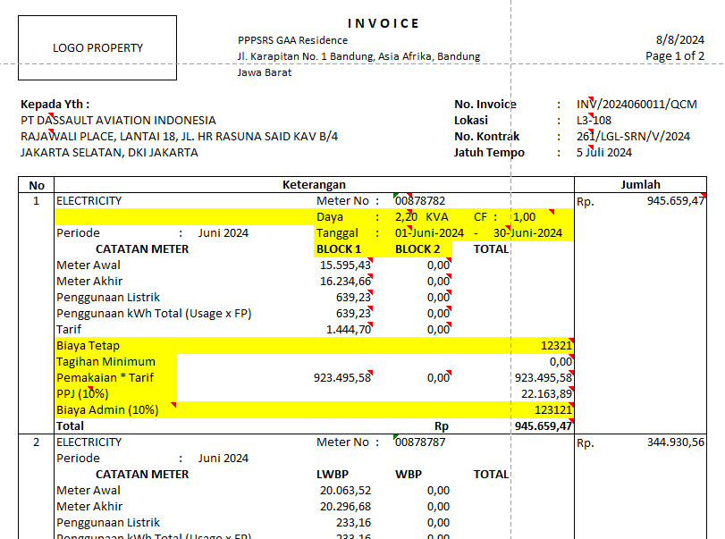

###### REPORT DEFINITION

|  |  |  |  |
| --- | --- | --- | --- |
| **Report** | **Name** | **Field** | **Validation** |
|  |  |  |  |
|  |  |  |
|  |  |  |
|  |  |  |  |
|  |  |  |
|  |  |  |  |
|  |  |  |
|  |  |  |
|  |  |  |
|  |  |  |
|  |  |  |  |
|  |  |  |
|  |  |  |
|  |  |  |
|  |  |  |
|  |  |  |  |
|  |  |  |
|  |  |  |
|  |  |  |
|  |  |  |
|  |  |  |
|  |  |  |
|  |  |  |
|  |  |  |
|  |  |  |
|  |  |  |
|  |  |  |
|  |  |  |  |
|  |  |  |
|  |  |  |
|  |  |  |
|  |  |  |
|  |  |  |
|  |  |  |
|  |  |  |  |
|  |  |  |
|  |  |  |
|  |  |  |
|  |  |  |
|  |  |  |
|  |  |  |

###### VALIDATION

|  |  |  |
| --- | --- | --- |
| **Field** | **Condition** | **Validation Message** |
| Property | Empty | Please select Property! |
| Cut Off Date | Empty | Please select Period Cut Off Date ! |
|  |  |  |
|  |  |  |
|  |  |  |
|  |  |  |
|  |  |  |

#### ACTION REFRESH

|  |
| --- |
|  |
| * Jalankan exec RSP_PM_GET_PROPERTY_DETAIL_INFO dengan parameter :   + - VAR_COMPANY_ID     - Selected Property Id     - VAR_USER_ID * Set Return into Parameter Report P_PROPERTY_NAME = CPOPERTY_ID + ‘ – ‘ + CPROPERTY_NAME * Set Return into Parameter Report P_PROPERTY_ADDRESS = CADDRESS + ‘ ‘ + CPROVINCE + ‘ ‘ + CCITY + ‘ ‘ + CDISTRICT + ‘ ‘ + CSUBDISTRICT * Set Return into Parameter Report P_PROPERTY_LOGO = OLOGO * Jalankan RSP_PM_GET_PMR01700_INVOICE_LIST dengan parameter untuk Main Report   + - VAR_COMPANY_ID     - Selected CPROPERTY_ID     - Selected CDEPT_CODE     - Selected CYEAR + Selected CMONTH (yyyymm)     - Selected CCUT_OFF_DATE     - Selected CBUILDING_ID     - Selected CFROM_FLOOR     - Selected CTO_FLOOR     - Selected CFROM_REFERENCE_NO     - Selected CTO_REFERENCE_NO     - Selected CFROM_REFERENCE_DATE     - Selected CTO_REFERENCE_DATE     - Selected CFROM_CUSTOMER_ID     - Selected CTO_CUSTOMER_ID     - Selected CFILTER_BY     - VAR_USER_ID     - Selected CINVOICE_MODE   Set Return into Grid |
|  |
|  |

#### DISTRIBUTE PROCESS

|  |
| --- |
|  |
| * Copy result report (need tenant id)   Check and drop if temp table exist  IF OBJECT_ID('tempdb..#TEMP_INVOICE_LOGIN') IS NOT NULL  DROP TABLE #TEMP_INVOICE_LOGIN   * Create Temp table #TEMP_INVOICE_LOGIN   CREATE TABLE #TEMP_INVOICE_LOGIN(  CCOMPANY_ID VARCHAR(20)  ,CPROPERTY_ID VARCHAR(20)  ,CTENANT_ID VARCHAR(20)  )  INSERT INTO #TEMP_INVOICE_LOGIN(CCOMPANY_ID, CPROPERTY_ID, CTENANT_ID) VALUES  (var_company_id, var_property_id, tenant_id from report),  (var_company_id, var_property_id, tenant_id 2 from report),  (var_company_id, var_property_id, tenant_id 3 from report),  … etc   * Run SP RSP_PM_GET_BODY_EMAIL_INVOICE with parameter :   + VAR_COMPANY_ID   + Selected Property Id   + VAR_USER_ID   Send Result with send mail framework |
|  |

### CR

|  |  |  |
| --- | --- | --- |
| CR | Description | Notes |
|  |  |  |
|  |  |  |
|  |  |  |
|  |  |  |
|  |  |  |

VALIDATION

|  |  |  |
| --- | --- | --- |
| **Field** | **Condition** | **Validation Message** |
|  |  |  |
|  |  |  |

ACTION

|  |
| --- |
|  |
|  |